UNIT 3 – Our First Governments
After Independence
- ___________________________, 1783
  - _______________________ the American Revolution and British Rule
- There were 13 individual colonies with 13 different governments
- The colonies became a _________________________ of the 13 states in a confederate style government that was totally unwritten
State Government
- ____________________ was the first colony to organize as a state & craft a written plan for government, or ______
- Other states formed similar systems of government
- Most state legislatures were ____________ (divided into two parts, or houses)
  - Members of the two houses were chosen by different methods
- Each state had an elected _______________ to carry out the laws and judges and courts to interpret the laws
- Most state constitutions included a ______________________
- The Massachusetts constitution was different from the others
  - It distributed power more evenly among the __________, _____________, and _____________
- It gave the governor and the courts the authority to check the legislature
- The Mass. Constitution would later become the model for the U.S. Constitution
Articles of Confederation
- Separately, the states could not maintain a large army to fight the British
- For this and other reasons, the Second Continental Congress made a plan for union called the_____________________________
  - A confederation is a group of individuals who band together for a common purpose
- The Articles set up a _______________ legislature
  - 1 vote per state
  - 9/13 required to pass laws
- As a result of bad experiences with the British government, the states refused to give Congress the power to _____ or enforce its laws
- Congress could not require the states to give money or do anything else
- The states _____________ (or approved) the Articles
- Soon, serious problems became clear. __________ voting requirements to pass laws or amend (change) the Articles made it difficult for Congress to accomplish anything
- Even when it passed laws, Congress could not enforce them. States could just ___________ the laws
- Unable to _______________, Congress had borrowed money for the war
- The states had also run up deep debts
  - to pay for their debts, the states overtaxed their citizens and even taxed goods from other states and foreign countries
  - the Confederate Congress had no power to solve these problems
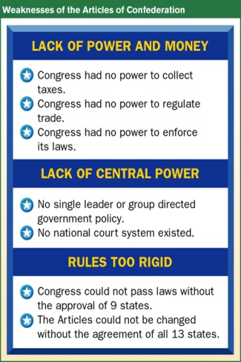
Land and Northwest Ordinance
- One thing that managed to pass during the Articles of Confederation was the:
  - ______________________ 1785 – land past the Appalachians were declared new territories
  - ______________________ 1787 – banned slavery in the Northwest areas and set up a process of adding additional states
Shay’s Rebellion
- Event that occurred when Daniel Shay, an indebted farmer, felt the state had no right to take his farm away because of a problem the state had created
- He led an uprising, known as __________________
- This unrest swayed leaders toward revising the Articles of Confederation to create a stronger national government

UNIT 3 – CONSTITUTIONAL CONVENTION
Who attended the Constitutional Convention?
- Each state except __________________ sent delegates to Philadelphia to fix the flaws in the Articles of Confederation
- Most of the 55 men were well educated and experienced in politics
  - Native Americans, African Americans, and women were not included
- ___________________ was the oldest delegate at 81
  - He was a diplomat, writer, inventor, and scientist
- Two delegates - _______________ & ________________ would eventually become president
- ______________ & ________________ could not attend
  - They were in Europe as representatives of the United States government
- ______________________ opposed the convention and did not attend
Who attended the Constitutional Convention?
- The delegates chose __________________________ to preside
  - He set a committee to set rules for conducting the convention
- The committee decided that decisions would be made by ______________, with each state having one vote
- Delegates agreed to keep all discussions secret to enable all to speak freely
- No formal records were kept
- Most of what we know comes from _________________ personal notebook of events
- The delegates decided to discard the Article of Confederation and write a new constitution
- Thus the meeting came to be known as the ________________________________
What were the two opposing plans?
- James Madison designed the __________________
  - It called for a government with three branches
    - __________________ (lawmakers)
    - __________________(carry out laws)
    - __________________(interpret laws)
  - The legislature would have two houses, with the states represented by basis of population
- The Virginia Plan appealed to the larger states
- The small states feared a government dominated by large states who would ignore their interests
- The _____________________________ also called for three branches of
  - The legislature would have _____________ and each state would get ______ vote
- This plan would give equal power to large and small states
What compromises were made?
- ____________________ committee proposed a Senate and a House of Representatives
  - Each state would have equal representation in the _______________. Representation in the House would be based on _________________.
- The delegates accepted the __________________ or the _____________________
- Southern states wanted to count enslaved African Americans as part of their population in determining representation in the House
  - Northern states opposed this plan
- In the _______________________, delegates agreed that every five enslaved persons would count as three free persons for determining congressional representation and figuring out taxes
- Northern states wanted congress to be able to regulate foreign trade and trade between the states
- Southern states feared Congress would then tax their exports and stop the slave trade
- The agreed to give Congress the power to regulate trade, but it could not tax exports or interfere with the slave trade before 1808
- Delegates disagreed on whether Congress or the voters should choose the president
- The solution was the ____________________, a group of people named be each state legislature to select the president and vice president
  - Today, the voters in each state, not the legislators, choose electors
Approving the Constitution
- Ratification required at least ___ out of _____ state conventions to vote “yes”
- Supporters of the constitution called themselves ______________ to emphasize that the Constitution would recreate a system of federalism
  - Power is divided between ________ and the ___________ governments
- Federalists argued for a strong central government
  - _______________ - Hamilton, Madison, Jay
- Opponents, the _________________, wanted more power for the states and less for the national gov
  - They also wanted a _______________ to protect individual freedoms
- Both agreed to ass a bill of rights. This promise turned the tide.
- The constitution took effect when __________________ became the ninth state to ratify it on ________________

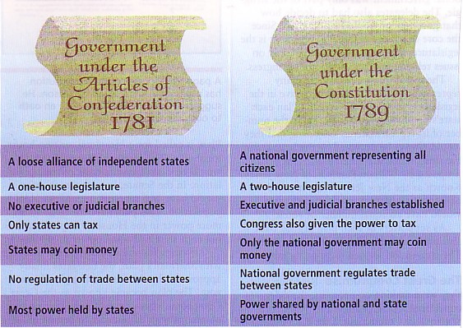
UNIT 3 – CONSTITUTION
The Constitution and its Parts
- The main purpose of the constitution is to provide a framework for government, but it is also known as the_____________________
- The powers of all branches come from it. It has three major parts: ______________, ________________, ____________________________
- The ______________ states the goals and the purposes of the gov
  - The first part makes clear that government gets its power from the people and exists to serve them
  - The middle part of the preamble states ______ purposes of government
    - ____________________________
    - ____________________________
    - ____________________________
    - ____________________________
    - ____________________________
    - ____________________________
- The ______________ explain how the gov is to work
  - The first 3 articles describe the powers and responsibilities of the three branches of government
- Articles I describes the _____________________ as two houses with _______________ authority
  - Describes how members will be chosen
  - Article also lists specific powers Congress does or does not have
- Article II establishes the _______________, or law enforcing, branch headed by a president and vice president
  - It explains how these leaders will be elected and can be removed and describes their powers and duties
- Article III establishes the __________________ to interpret and apply the law
  - It calls for one _________________ plus lower courts and describes the power of the federal courts
- Article IV says that all states must respect one another’s laws and explains the process of creating _____________. This is known as the “__________________________.”
- Article V specifies how the constitution can be amended
- Articles VI declares the Constitution as the “_______________________” and federal law prevails over state law, this is referred to as the “__________________”
- Article VII states that the constitution would take effect when 9 states ratify it
UNIT 3 – CONSTITUTIONAL PRINCIPLES
Six Principles of the Constitution
- The Framers had a common vision for the government:
  - It should be representative of the people and limited in scope
  - The powers should be divided among different levels
- To achieve these ends, the Framers embraced six principles as the backbone of the Constitution
  - _______________________________________
  - _______________________________________
  - _______________________________________
  - _______________________________________
  - _______________________________________
  - _______________________________________

What is Popular Sovereignty?
- Article IV guarantees a __________, in which supreme power belongs to the people - _____________________
- The people express their will through elected _____________________
- Provisions, such as those about the _________________, ensure popular sovereignty
What is Rule of Law?
- The Framers believed the government should be strong but not too strong
- The constitution sets limits by stating what the government may and may not do
- Government is also limited by the __________________
  - This means that the law applies to __________, even those who ____________
What is Checks and Balances?
- Checks and balances keep any one branch from becoming too powerful
- Each branch can check, or ____________, the power of the others
  - For example, the president can veto laws, congress can block presidential appointments, and the Supreme Court can overturn laws it finds contrary to the Constitution
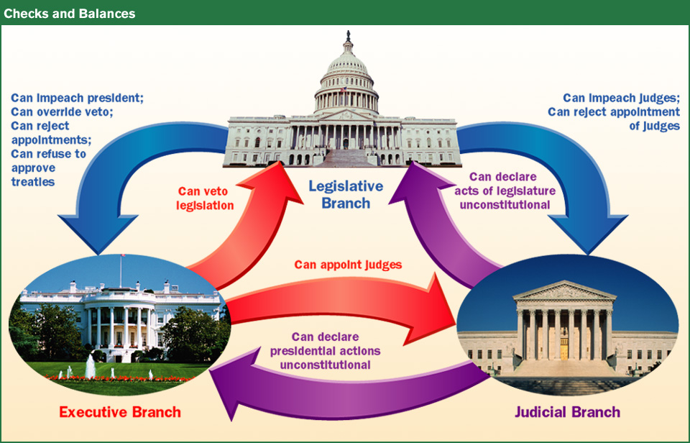
What is the Separation of Powers?
- To ___________________________________________, the framers divided government into three branches with different functions.
- This split of authority among the_____________, _______________, and ______________ branches is called the separation of powers
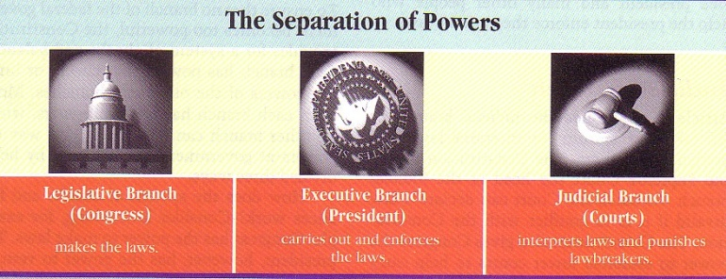
What is Federalism?
- Under federalism, power is shared by _____________ gov and _______________
  - Americans must obey the law of both
- _________________, expressed, or delegated powers are powers the Constitution specifically grants to the ___________________________
- Powers NOT given to the national government are _______________ powers kept by the states
- Powers that BOTH levels of government can exercises are __________________ powers

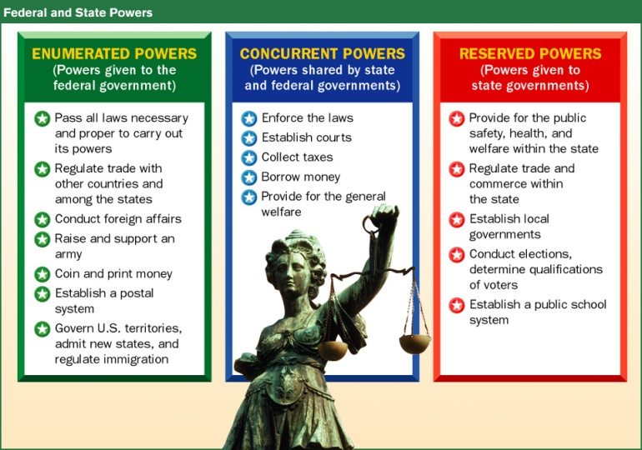
- When national and state laws conflict, the Constitution is the final authority
  - _____________________
- Neither the national nor state governments may act in violation in it
- The Constitution is durable and ____________
- It provides the government sufficient power to keep order, protect, and defend, yet sets limits to avoid ________________

Why is it flexible?
- The constitution is flexible so that it may change to __________________ over time
- Different circumstances may cause the constitution to ___________
- Equality Amendments
  - 15th - ________________________
  - 19th - ________________________
  - 26th - ________________________
UNIT 3 – CHANGING THE CONSTITUTION
Over 200 years old, still functions because of its flexibility, and it was only meant to be a blueprint or framework
How can you amend the Constitution?
- An _______________is any change to the Constitution
  - The first _____ are the ________________________
- The Framers made sure that the Constitution could not be altered without overwhelming support of the people
- Only ______ amendments have become law
- The amendment process involves two steps: ________________ and _____________________
- An amendment may be proposed by a vote of _________ of both houses of Congress or by the national ________________ requested by ___________ of the state legislatures
  - Once proposed, and amendment must be ____________ by _________ of the states
  - The states can do this by a vote of either the state legislature or a special state convention
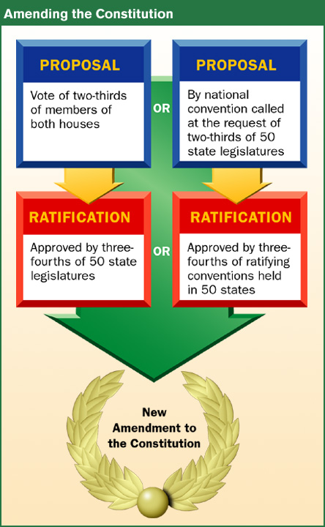

Interpreting the Constitution
- The constitution is a general document _____________________________________________
- _____________ gives Congress the power to “____________________________________” to carry out its duties
  - This ____________ and ____________ clause or “elastic clause,” allows Congress to exercise implied powers not specifically listed in the Constitution
  - Americans disagree on what laws are “necessary and proper”
    - _______________________ - believe Congress can make any laws not specifically forbidden
    - _______________________ - believe Congress can make only the kinds of laws mentioned in the Constitution
- The ___________________ has the final authority on interpreting the Constitution
    - Each new interpretation, whether it’s strict or loose, changes our gov
- Again, the Framers wrote the Constitution to be __________
- Actions by Congress and the president have also caused new interpretation
  - For example, the president requests legislation from Congress
  - This action is NOT directed by the Constitution
- _____________ also changes the interpretation of the Constitution
  - For example, political parties, NOT mentioned in the Constitution are part of today’s political system
UNIT 3 – BILL OF RIGHTS
Bill of Rights
- The Bill of Rights, added in ______, protects our civil liberties:
  - The freedoms we have to thing and act without government interference or fear of unfair treatment

1st Amendment
- The First Amendment protects five basic freedoms:
  - _________, __________, __________, ____________, and _____________
- Congress may not establish an official religion, favor one religion over another, treat people differently because of their beliefs
  - ______________________________
- People may practice their faith as they wish
  - ______________________________
- In some countries, people can me jailed for criticizing the government or voicing unpopular ideas
- We can say what we want, in public or in private, without fear of punishment
- Freedom of speech includes conversations, radio, and TV
- It also protects forms of expression other than the spoken word, suck as clothing.
- We may express ourselves freely in print and other media
- The government cannot practice _______________
  - It cannot ban printed materials or films because they contain offensive ideas or ban information before it is published or broadcast
- We may gather in groups for any reason, as long as the assemblies are _______________
- Governments can make rules about where and when activities can be held but cannot ban them
- We may freely join clubs, political parties, unions, and other organizations
- We have the right to ______________ the government
  - A petition is a ___________request
- We can also complain or express ideas by writing to our elected representatives
What are the Limits to First Amendment Freedoms?
- The __________________________ has decided that the 1st Amendment freedoms may be limited to protect safe3ty and security
  - ______________________________________
- You may not provoke a _____________
- You may not speak or write in a way that leads to ______activities or efforts to overthrow the government
- You should use civil liberties responsibly and not interfere with the rights of others
- You may criticize government officials but not spread lies that harm a person’s reputation
  - Slander_________________
  - Libel___________________
- ______________freedom is not possible in society
- The rights of one individual must be balanced against the rights of others and of the community
How does the Constitution protect the Rights of the Accused?
- The _____, _______, _______, and __________ amendments protect the rights of accused people.
- The _______ Amendment
  - Protects against unreasonable searches and seizures
  - If police believe you have committed a crime, they can ask a judge for a _______________
    - A court order allowing law enforcement officials to search a suspect’s home or business and take evidence
    - Search warrants are only granted with good cause
- The _______ Amendment states that no one can be put on trial for a serious crime without an _______________
  - A formal charge by a group of citizens called a __________________, who review the evidence
  - An indictment doesn’t mean guilt – it indicates only that the person may have committed a crime
  - The fifth amendment also protects against ____________________
    - Someone tried and judged not guilty may not be put on trial again for the same crime
  - The fifth amendment also protects an accused person’s right _____________________
    - This prevents a person from being threatened or tortured into a confession
  - It also states that no one may be denied life, liberty, or property without ________________
  - Limits _____________________
    - The right of gov to take private property (usually land) for public use
- The _______ Amendment requires accused people to be told the charges against them and garuntees a trial by jury unless the accused chooses a judge instead
  - Trials may be speedy and public with impartial jurors
  - Accused people have the right to hear and question witnesses against them and call witnesses in their defense
  - Accused people are entitled to_____________
  - Before the trail, the accused must stay in _____ or pay _______, a security deposit
  - Bail is returned if the person comes to court for trial but is forfeited if the person fails to appear
- The ______________ amendment forbids excessive bail and excessive fines
  - It also forbids _______ and ___________ punishment
  - Punishment must fit the crime
How does the Constitution protect other rights?
- The _________ amendment is often debated
  - Some people believe it only allows states to keep a _________, or local army
  - Some believe it guarantees the right of all citizens to “_____________________________”
  - The courts have generally ruled that government can pass laws to control, but not ______________, the possession of weapons
  - A well regulated militia, being necessary to the security of a free state, the right of the people to keep and bear arms, shall not be infringed
- The ________ Amendment says that soldiers may not move into private homes without the owners consent, as British soldiers had done in colonial times.
- The _______ Amendment concerns ______________
  - Lawsuits involving disagreements among people rather than crimes
  - It guarantees the right to a jury trial in civil cases involving more than ____ dollars
    - It does not require a jury, however.
- The _______ Amendment say that citizens have other rights beyond those listed in the Constitution
- The _______ Amendment says that any powers the Constitution does not specifically give to the national government are reserved to the states or to the people
  - This prevents ________ and the ___________ from becoming too strong
    - The only have the powers the ___________ give them
UNIT 3 – CONSTITUTIONAL AMENDMENTS
Protecting All Americans
- At first, the Bill of Rights applied only to ___________________
- It also applied only to the national government, not to state or local governments
- Later amendments and court rulings made the Bill of Rights apply to all people and all levels of government
- The ________________ amendments
  - ____, _____, _____
    - Extended civil liberties to African Americans
  - 13th – outlawed __________
    - “Jim Crow Laws” __________________
  - 14th – defines citizens as anyone born or naturalized in the US; included African Americans
    - It required all states to grant citizens __________ protection of the laws
    - Also nationalized the ______________ by forbidding state governments from interfering with the rights of citizens
  - 15th – gave African American men the __________________
    - It was intended to guarantee _______- the right to vote- to African Americans
    - It allied only to _______
- The Constitution did not grant or deny __________ the right to vote
  - As a result, the states made their own decisions
- ______ Amendment gave women the right to vote in all elections
- Because Washington, D.C. is a district, not a state, its citizens could not vote in national elections
- ______ Amendment established the right to vote for Washington, D.C. residents
- Several Southern states required a _____ tax to vote
  - Because many Afircan Americans and poor whites couldn’t afford to pay, they couldn’t vote
- ______ Amendment outlawed poll taxes
- ______ Amendment granted voting rights to ____ yr olds
  - Before this, the age was set at 21 by most states
- ______ Amendment states term limits for the office of the president - _____ years in office
- ______ Amendment states the order of succession for the office of the president
- ______ Amendment – places limits on suits against states
- ______ Amendment – changes procedure for electing President and Vice-President
- ______ Amendment – gives the authority to levy income tax
- ______ Amendment – direct election of Senators
- ______ Amendment – Prohibition of Alcohol
- ______ Amendment – changes beginning of Presidential and Congressional terms
- ______ Amendment – Repeals Prohibition
- ______ Amendment – places limits on Congressional pay raises until the beginning of the next term

